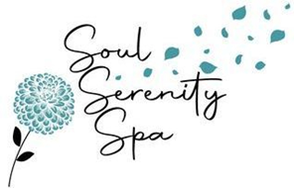Do you have the skills to be our next Nail Technician? Soul Serenity Spa is hiring for full-time or part-time positions!
If you’re a skilled nail technician looking to advance your career and build a client base, Soul Serenity Spa in Coxsackie, NY is the perfect opportunity for you. Our recently opened nail spa has a proven track record of repeat clients, and we’re searching for a knowledgeable and energetic nail tech to join our team. The ideal candidate should have expertise in regular / gel manicures and pedicures, ANC/dip powder, gel builder, and facial waxing. If you have any combination of these skills, we encourage you to apply.
The position is paid out weekly based on commission. We’re looking for individuals who possess excellent communication skills and work well with others. You must hold a valid Nail Specialty, Esthetician or Cosmetology license, and be able to work with our scheduling system to make appointments and handle phone calls. In addition, you should maintain a great level of knowledge regarding nail care for both hands and feet, and have complete knowledge of all spa services presently offered. You will be required to assist the Spa in various activities like staff meetings, clean-up, and housekeeping duties. As an employee of Soul Serenity Spa, you must uphold the standards of sanitation and sterilization as directed by law. Finally, you should assess customer needs, identify appropriate nail care options, and suggest solutions to meet their needs.
If you’re interested in applying, please send your resume to Savanah Beers owner of Soul Serenity Spa at Soulserenityspa2021@gmail.com. For any questions, feel free to contact us by email as well.
Savanah Beers / www.soulserenityspa.org / 22 Hope Plaza, West Coxsackie NY 12192

